Paul Hamlyn (1926–2001)

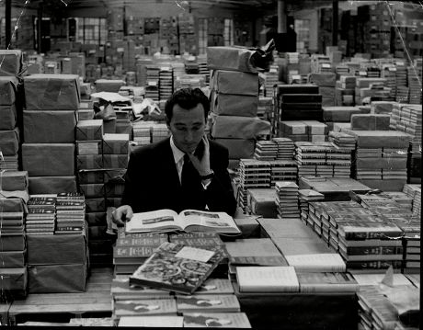
Paul Hamlyn, originally Hamburger, anglicising his name after arriving in the UK. The migration of his Jewish family was forced due to the rising Nazi power in Germany. Educated at St Christopher School in Letchworth. He left school without going to university and entered the book trade.
Paul Hamlyn began his publishing career selling books from a barrow in Camden, opening his first imprint, Books for Pleasure, in 1949. This was his modus operandi; classics sold through unconventional outlets; general shops and department stores rather than bookshops. His books were produced in large, cheap editions. His choice of printers in Czechoslovakia who could produce lavishly illustrated books at a rock-bottom price. The story may well be apocryphal but it is alleged that there were points at which Paul Hamlyn’s Books for Pleasure were using 100% of Czechoslovakia’s publishing capacity.
On 25 August 1965, Hamlyn alongside EMI chairman Sir Joseph Lockwood announced the formation of Music for Pleasure. Hamlyn's contribution to MFP was structural: the distribution network into non-traditional retail that he had spent fifteen years building for books. EMI provided the catalogue and pressing capacity and Hamlyn provided the sleeve printing and route to market.
Hamlyn was appointed CBE in 1993 and made a life peer in 1998 as Baron Hamlyn of Edgeworth. He established the Paul Hamlyn Foundation in 1987.
By all accounts, unlike the media megalodons of today, he was a decent person. This is my favourite description, from David Owen, "not a politician, but by nature on the side of the underdog."

